|  |  |  |  |  |  |
| --- | --- | --- | --- | --- | --- |
| Date | 11-Dec-22 | | | Tester Name | Andrew McLaughlin |
| Environment | Penfax - Test | | | Login used |  |
| Operating System | Select OS | Version: | Update: | | |
| Software Used | Select Software | Version: | Update: | | |
| Select Software | Version: | Update: | | |
| Release version | 22.4.1 | | | | |
| Title | Old plan members can be adjusted to the new amounts | | | | |
| Test Type | Regression | | | | |
| Test Scenario | Old plan members can be adjusted to the new amounts | | | | |
|  |  | | | | |
| Expected Results | When old plan members turn 65, they have manually reduced incomes:   * We should be able to retrieve the list of members who need to be adjusted. * We should be able to end previous benefits with Benefit Expiry and start new benefits with Government Benefit Integration. * Afterwards the Payroll Reduction Report should produce letters for members with reduced incomes netting more than a $10 difference. * The letters should be accessible under Communications and Outbound Documents. | | | | |
| Pass/Fail | Pass | | | JIRA# | N/A |

Describe your steps with screenshots:

After payroll for the previous month has been run, the Payroll Reduction Report batch process can be run to determine who will have a reduction in the following month

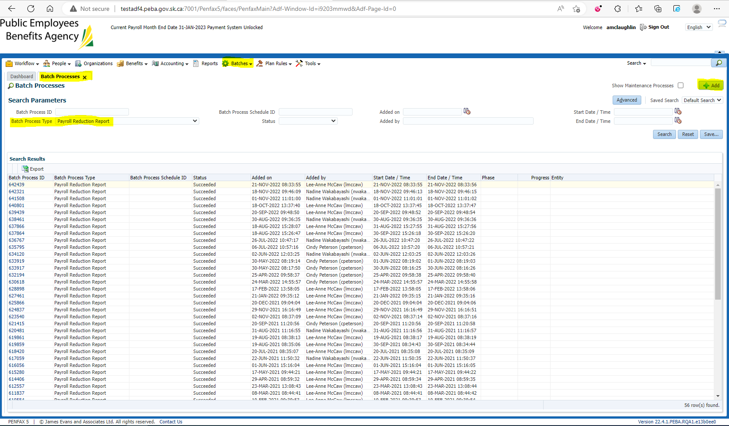

Open the generated batch and open the .csv file to view the members who are receiving reductions next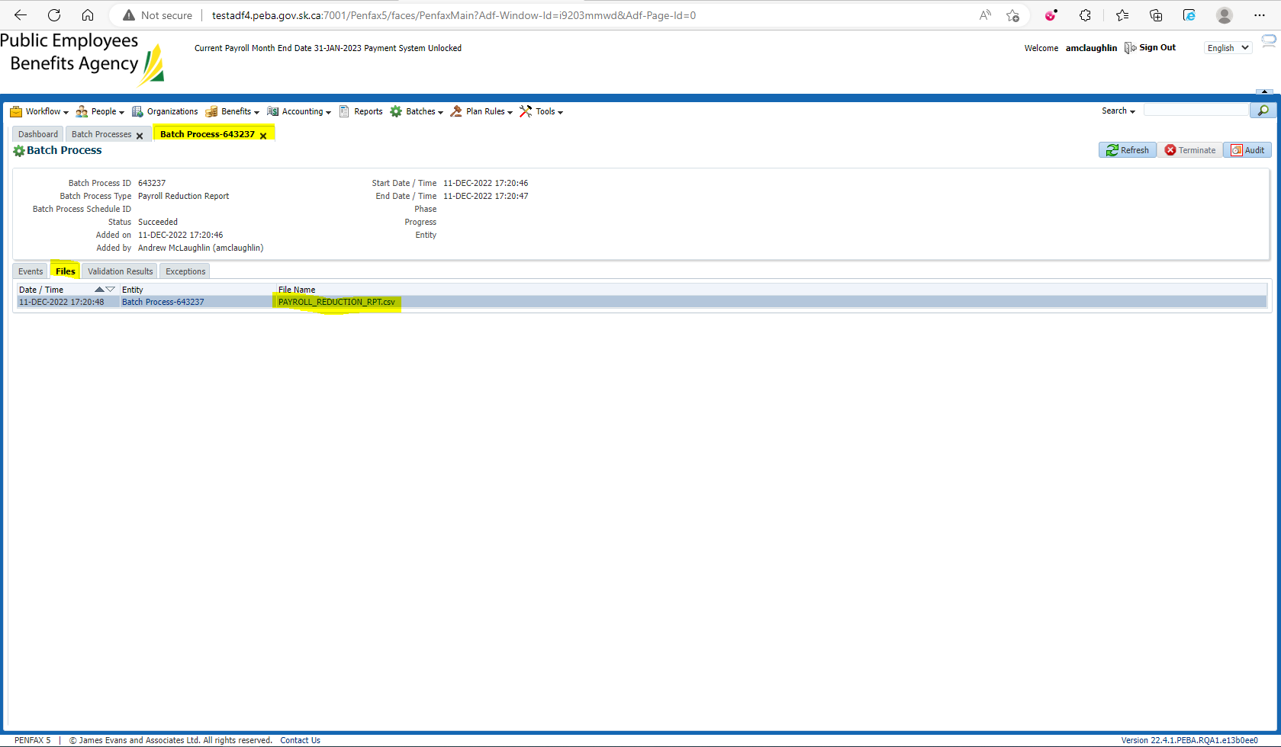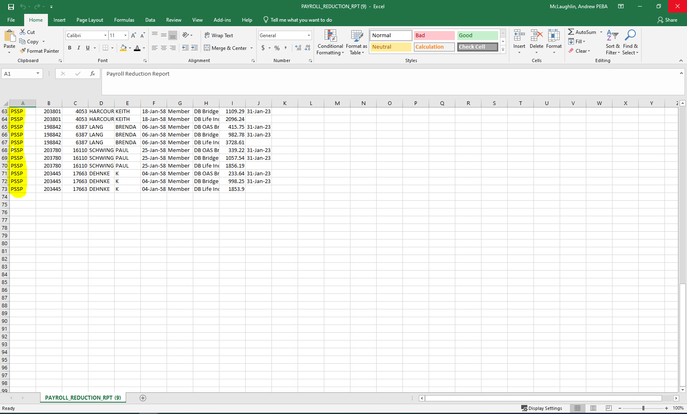

Old Plan (PSSP, PCSP, and LCB) members need to be manually adjusted. Under each member’s Benefit Recipient, Income Benefit, End All for the month that they turn 65 with the reason Bridge Expiry. 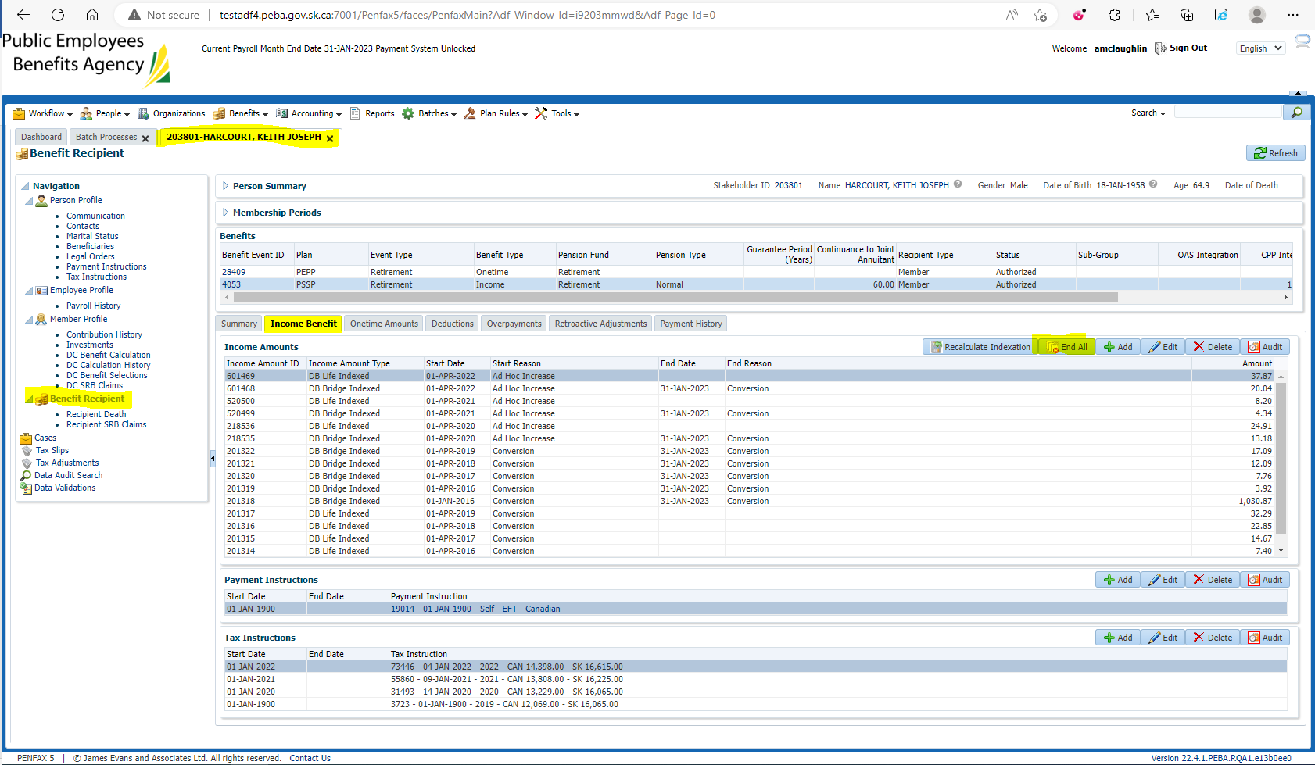 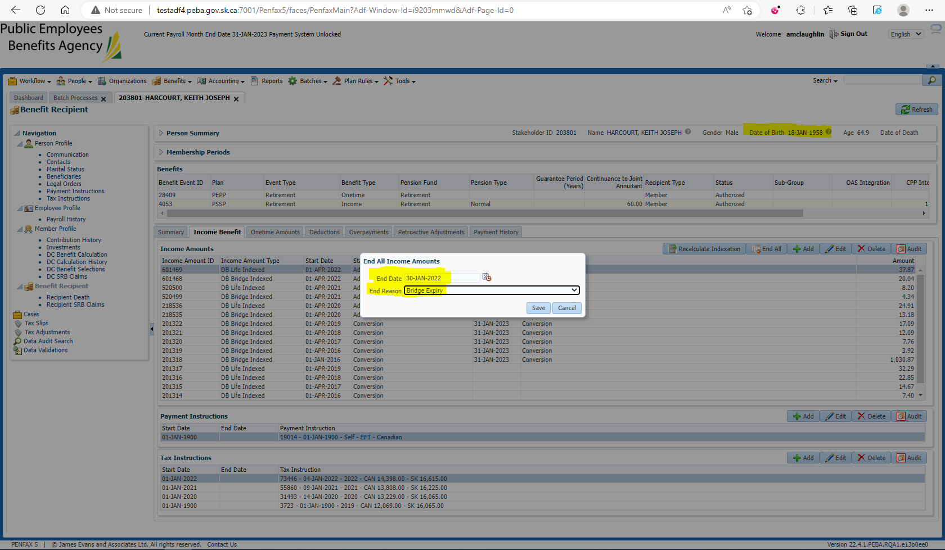

Add a new Income Type for DB Life with the new amount (manually calculated in practice, imagined for this test), starting the 1st day of the month after their birth month, as a Government Benefit Integration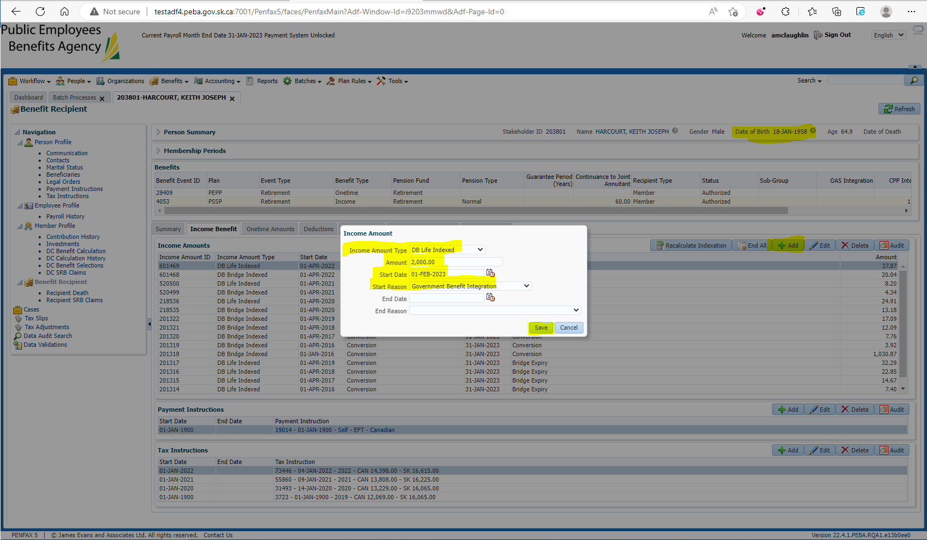

Run the Pension Payment Change Letters batch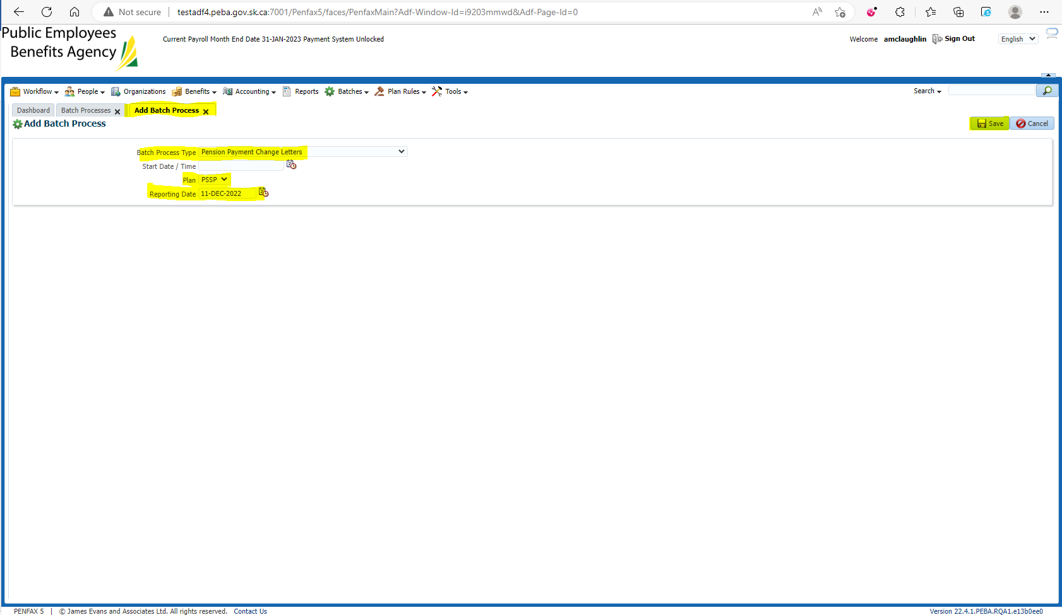 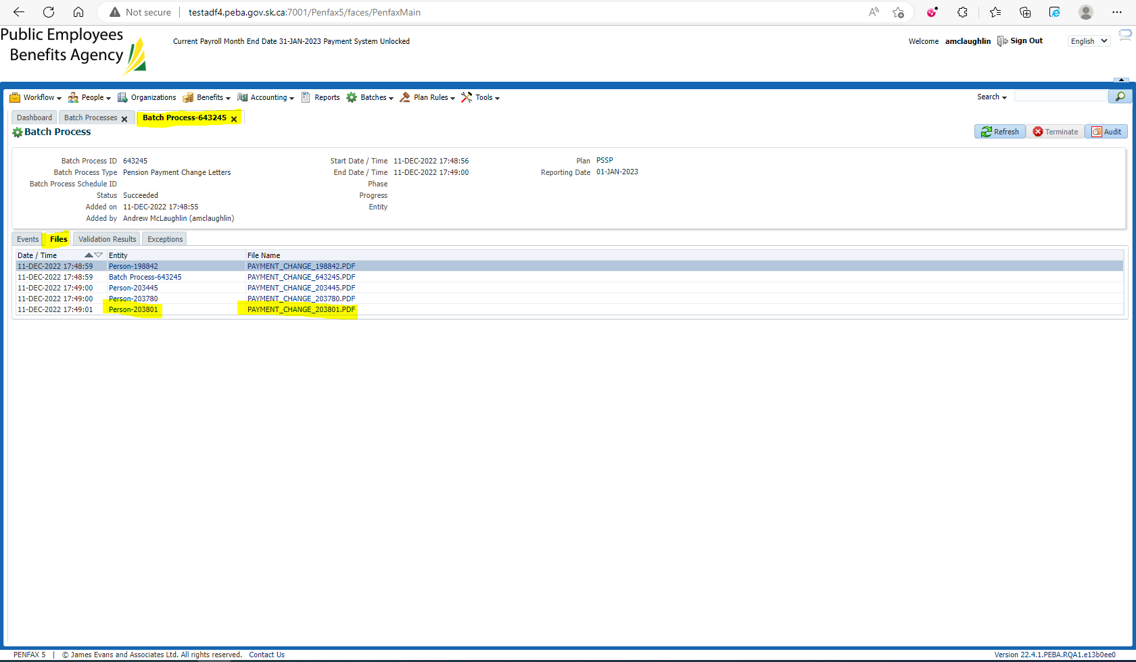

Open the Group PDF to compare against the .csv file 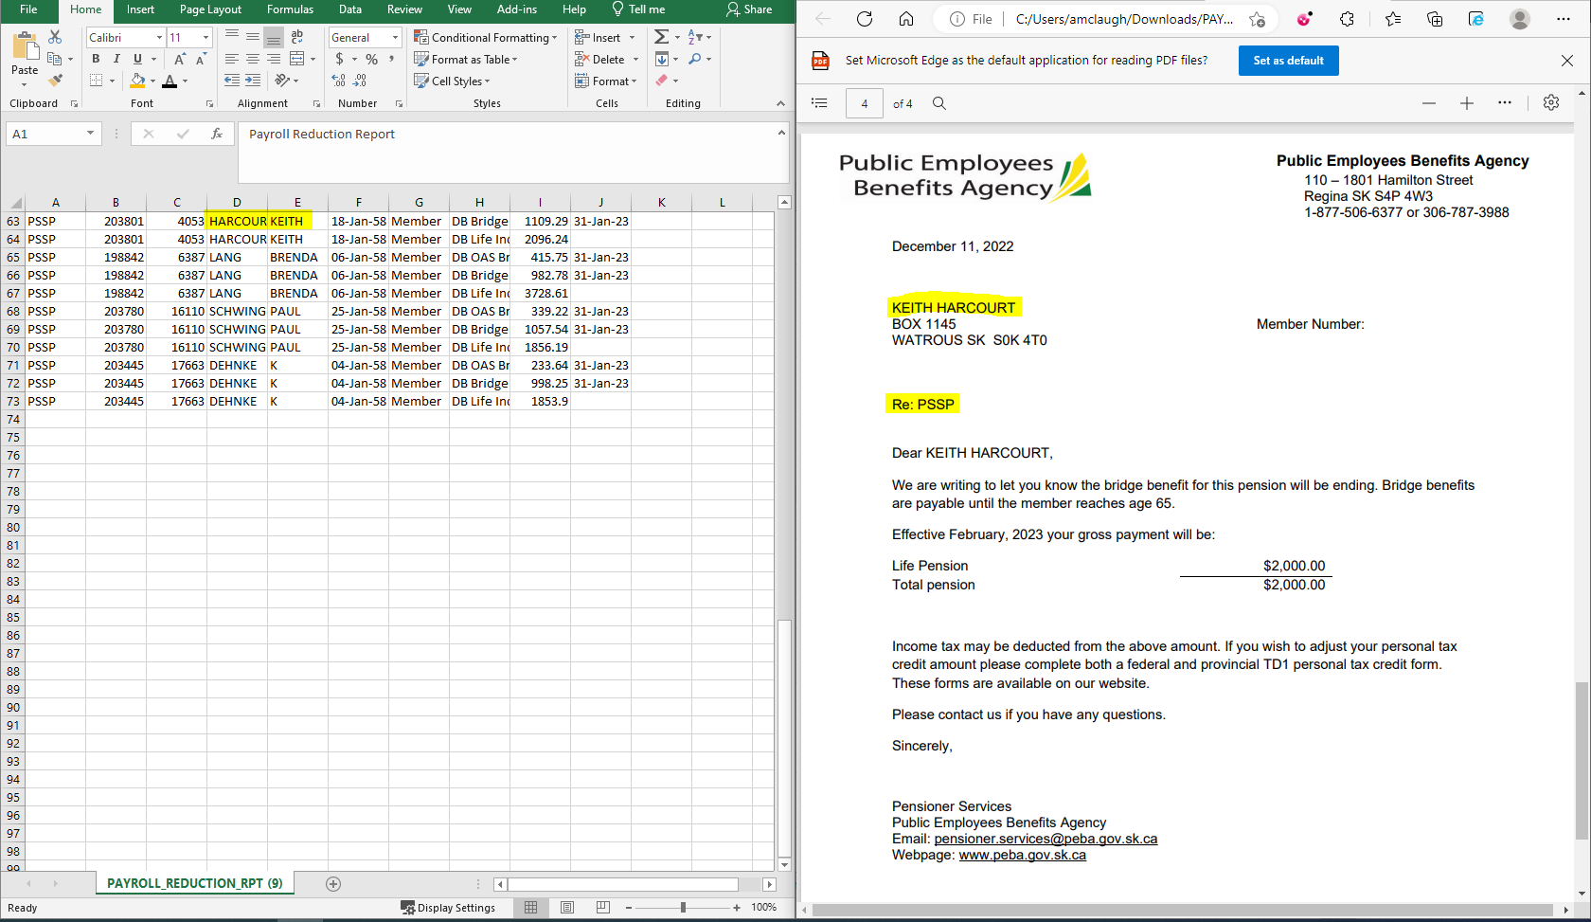

Verify that the letter has been added to the Member’s Outbound Communications